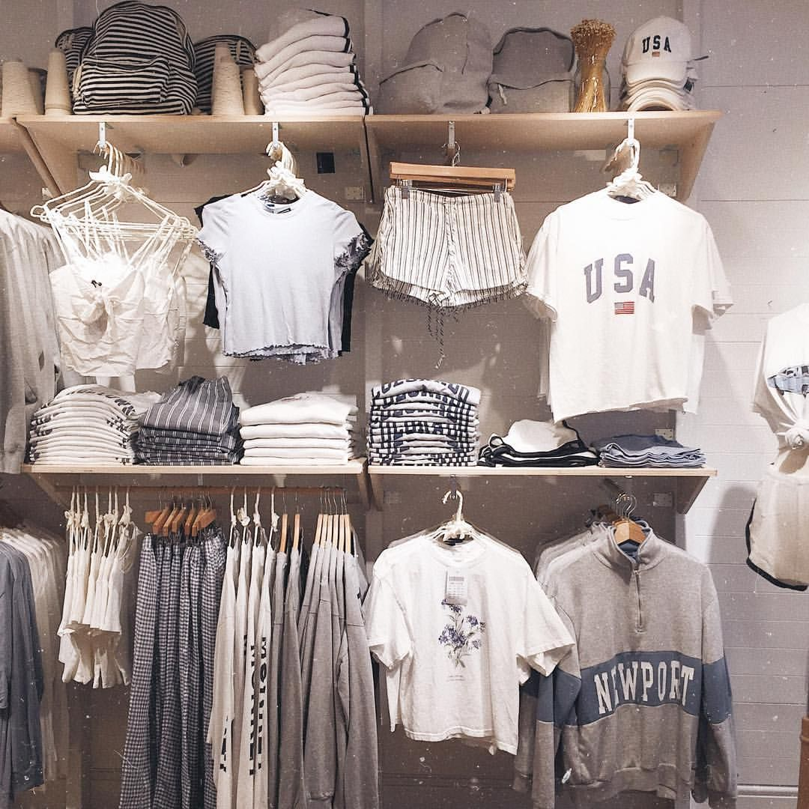

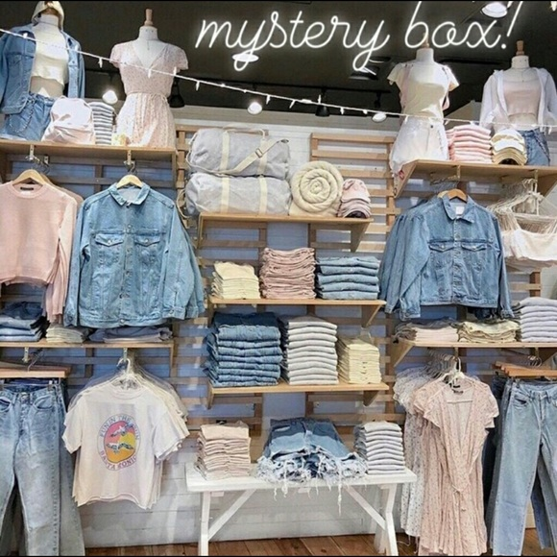
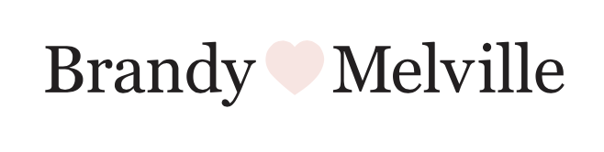

Crisis Response & Reputation Management

Maya Malekian
April 2020
About the Company

Brandy Melville is a clothing brand catered to females ranging in age from pre-teen years (12-13) to women in their late 20s. Established in 1970 by father-and-son pair, Silvio and Stephan Marsan, the privately held company has expanded over the years with a total of 154 locations worldwide—96 of which are in 23 states in the US. Brandy Melville first opened its doors in California with the help of Jessy Longo who brought the company from Italy in 2009. Its second largest market is in Europe with a total of 48 stores across the continent. Brandy Melville recently opened locations in Asia and Australia as well. The company’s ecommerce business contributes largely to its financial success—with the most recent estimate that the company made $125 million in revenue in 2014 and projects a 20-25% annual growth rate (The Financial Times).
The apparel is inspired by the product research team, comprised of young teenage girls who are up to date with the latest trends and advise of new product styles. This business strategy in addition to its aesthetically pleasing and laidback Instagram, which has over four million followers, has been attributed to the company’s popularity amongst its target demographic. Employees are primarily high school or college students and some model for the company as well as professionally. In recent years, the company has established relationships with fashion and lifestyle influencers who share photos and videos of them in Brandy Melville clothes in exchange for free merchandise and experiential opportunities.
Brandy Melville can also be found at Nordstrom and PacSun retails stores with only a select set of merchandise available.
Crisis Background

Brandy Melville’s exclusionary reputation has been linked to its identity since the company’s inception. The trendsetting, fast fashion store only offers one size in most garments except for some styles of pants, which has sparked controversy and some consumers even boycotting the brand for body-shaming and contributing to eating disorders and mental health issues.
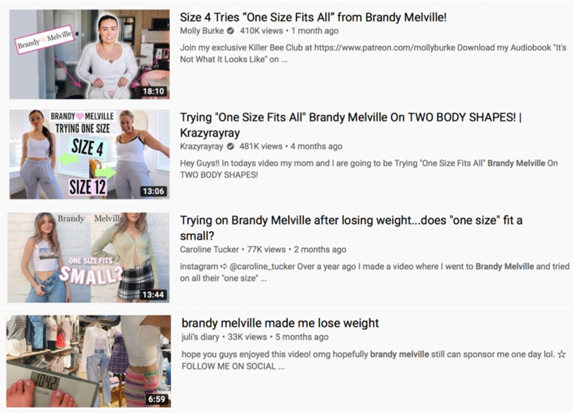

Figure 1: Search results for "Brandy Melville" on YouTube
YouTube videos, blogs and tweets circulate the Internet commenting on the company’s contentious business strategy alongside articles with headlines such as, “Brandy Melville Epitomizes What Is Wrong With Our Society” (The Cut). If an individual were to search Brandy Melville on YouTube, they would come across a trend of videos where girls ranging in sizes try to fit into Brandy Melville apparel. Most notably, Letao Chen released a video essay on YouTube titled “I lost weight to fit into Brandy Melville” in August 2019, which had over 4 million views and more than 11 thousand comments. Moreover, the company is notoriously known for threatening to file lawsuits against individuals who share negative experiences with Brandy Melville on social media.

Brandy Melville has never responded to criticism on its “one-size” policy nor has it made comments to the press except for Jessy Longo, whose leadership position in the company is undisclosed publicly. Longo’s problematic response in a 2013 interview with USA Today can no longer be found on the publication’s site.
“We can satisfy almost everybody, but not everybody," said Longo. "The one-size-fits-most clothing might turn off somebody if they don't walk into the store, but if you walk in, you'll find something even if it's a bag.”

In addition to continuous backlash over its sizing policy, recent accusations shed light on the company’s reputation for hiring employees and models who are predominantly white and thin adolescent girls. An exposé released on the front page of the New York Times’ Sunday paper revealed multiple cases of unethical business practices described by former employees of the company.* The trending article includes firsthand recollections by unnamed sources of alleged employment discrimination based on body type and skin color.

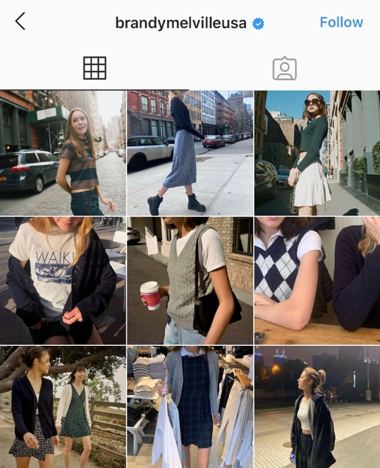
Figure 2: Snapshot of Brandy Melville's Instagram (@brandymelvilleusa)

*This is a fictional scenario created to exacerbate previous crises and relevance to the present.
Initial Response to Crisis

In light of the recent allegations, Brandy Melville needs to assess its crisis response strategies and establish key messages prior to issuing any form of response. The NYTimes exposé has severely damaged the company’s reputation with its viral nature of circulation and has fueled a domino effect of allegations as more individuals speak out against the brand in relation to employment discrimination and its sizing policy.
Postures and Strategies
This is not Brandy Melville’s first crisis and awareness of that notion is crucial. It impacts the severity of the crisis and the weight a response will carry, especially when the company has remained silent for years. The context of today’s cultural and social movements also influence how Brandy Melville will approach the crisis. With body positivity and inclusivity reforming the fashion industry, Brandy Melville’s delayed reaction to the movement puts itself at a disadvantage and calls for an immediate acknowledgement of the company’s responsibility in its social setting.
Since the crisis at hand and previous crises were largely preventable by the company, Brandy Melville is held responsible for its organizational misdeeds. Therefore, the company should approach the crisis with a strong rebuilding posture and supplementary bolstering to help the company advance its long-term plan for recovery.
Posture | Strategy | Prevalence in Response
Rebuilding | Apology | 60%
Bolstering | Ingratiation | 30%
 | Reminding | 10%

Figure 3: Posture and Strategies for Brandy Melville’s Response (Coombs, 2016b)
- Apology: This must be the primary strategy in communicating to stakeholders. Although the allegations made against the company need to be investigated, even speculation of unethical business practices warrants an expression of remorse when transparency has not been a driving force in previous communications (or lack thereof). Additionally, an apology is long overdue for the company’s disreputable sizing policy, which has upset stakeholders for years. While the former apology has to be made cautiously to avoid legal liability as the investigation is ongoing, the latter involves Brandy Melville accepting full responsibility, expressing its sorrow and regret and promising change.
- Ingratiation: Ingratiation is an important aspect of Brandy Melville’s crisis response, because it is a logical expectation that a company in tune with the latest fashion trends coming straight from its target demographic should also be listening to them when they present their concerns. This is especially true when allegations are made by internal stakeholders who represent the brand. This strategy will help Brandy Melville appear less defensive and more cooperative with stakeholders in its road to recovery. Ingratiation and apology should be the primary focus of communication at the onset of crisis response.
- Reminding: The reminding strategy should be used sparingly and only to rebuild Brandy Melville’s trustworthiness and credibility as a leading brand in trendsetting, affordable fashion rather than to detract from the remorse the company feels for compromising relationships with stakeholders. Reminding is an advantageous tool to help anchor all communication with key messages and to support the company’s pledge to be better in the future. It gives Brandy Melville the opportunity to highlight important strengths in the company, such as its youth-centered business strategy, which has developed brand loyalty from consumers. Brandy Melville designs its apparel based on input from its product research team comprised of teenage girls. This product development process is what makes Brandy Melville stand out from its competitors and the reason it has been credited for perfectly understanding its consumers and their tastes and for delivering the product to accommodate them.
Key Messages

Key messages are important for internal and external stakeholders to understand the company’s position and plan of action in response to the crisis. It is essential for any crisis communication as it supports the company’s image repair strategy and helps the media and the public to quickly and accurately identify Brandy Melville’s response. The following are key messages that all communication from Brandy Melville will need to include:
- Who We Are
- Our Story: Brandy Melville is a family company that has been around for over 50 years. Founded in Italy and later establishing our home in the United States, Brandy Melville apparel is offered worldwide through store locations and e-commerce.
- Our Values: We want young women to love their Brandy Melville apparel not only for how they look in them but for how they feel in our clothes.
- Our Brand: Brandy Melville is more than just a clothing brand. We are trendsetting fashion inspired by young women for young women all over the world.
- What We’re Doing
- Our Responsibility: We recognize our mistakes and sincerely apologize for not embracing our responsibility in advocating for inclusivity and transparency.
- Our Gratitude: We appreciate our customers and employees who are helping us learn from our errors, and we promise to not disappoint them and exceed their expectations as we move forward.
- Our Commitment: We are committed to understanding the root of our former employees’ frustration and take the opportunity to improve our company culture and business practices. This is a vital chance for us to strengthen our relationships with employees and customers for the long run.
- How We Will Be Better and Move Forward
- Our Promises: We promise to be a fashion brand that fosters individuality, inclusivity and body positivity from our clothing design to our employee relationships, customer outreach and everything in between. We also promise more transparency and open, two-way communication with our employees and customers as they are an essential part of our journey and who we are.
- Our Transformation: Our first responsibility is to make the appropriate changes to our practices based on the frustrations and feedback expressed by our employees and customers. This entails assessing our company culture and offering programs and guiding principles to strengthen our internal culture to reflect in our everyday interactions with our valued customers. We also are changing our sizing policy to include garment sizes for all body types and to promote body positivity and inclusivity in all of our stores and on all of our platforms.
- Our Support: We are committed to collaborating and consulting with experts and our stakeholders in a plan for recovery from how we hire, to the clothes we design, the messages we push forward and the social responsibility we assume.
Furthermore, it is pertinent for the company to not only understand what the response is addressing but also who it is addressing.
Key Stakeholders

Figure 4: Diagram of key stakeholders ranking in importance from top to bottom (Grunig, 2005)
Plan of Action

Figure 5: Plan of Action
The tactics described in phase one of the above diagram will be important to communicate immediately. A formal statement from the company expressing an apology and plan of action should be disseminated on all platforms and shared to the press. Simultaneously, Brandy Melville will need to actively work with the company’s legal team and the Equal Employment Opportunity Commission to verify the claims and respond to the impacted parties. Another focus in the company’s initial response should be implementing programs aimed towards rebuilding, such as setting up call centers for employees and customers as well as establishing a diversity and inclusion committee to guide communication and any policy changes.

Brand Reputation and Image Repair Strategy

The following sections provide a comprehensive overview of strategies pertaining to phase two and three for improving Brandy Melville’s reputation and learning from the crisis.

Media Relations
Brandy Melville has a notorious history of being “press-shy”. However, this brand transformation involves the company assuming responsibility for dealing with press inquiries and actively seeking opportunities to engage with media outlets. This new mindset requires a new addition to executive leadership: Brandy Melville’s media spokesperson, Jennifer Foyle. She previously served as the Global Brand President for Aerie and lead the company’s body positivity initiative in addition to setting the strategic vision for the brand.
Following an initial statement from executive leadership, Foyle will need to hold a Q&A interview with select media outlets to address the crisis. Brandy Melville should invite Hayley Peterson who writes in-depth investigations on public and private companies for Business Insider, beauty and style writer Sue Williamson from Teen Vogue, Katy Schneider from The Cut who wrote an opinion piece in 2019 titled “The Secret Shame of Wearing Brandy Melville” and the author of the exposé Jessica Silver-Greenberg from The NYTimes for an interview at the company’s headquarters in New York City.
Once a relationship is established with media, the company can pitch angles to media outlets to support its transparency efforts and overall brand reputation and image repair. For instance, Brandy Melville can take reporters “behind-the-scenes” to reveal how the product research team made up of teenage girls creates new styles and finds inspiration. A similar approach has been previously done by YouTubers that Brandy Melville works with but offering it exclusively to media outlets can increase exposure.
Another pitch opportunity entails an interview with Brandy Melville’s social media manager and lead visual merchandising manager. A multimedia piece on how the company develops its unique aesthetic both in stores and on social media would generate large amounts of publicity.
Lastly, the best way to emphasize Brandy Melville’s key message of a brand made by women who wear it is to invite broadcast media like The Today Show to a Brandy Melville casting/photoshoot featuring customers, employees and its established influencer partners. The photos from the shoot can later be shared on social media and the website as a “lookbook” for further publicity.
Utilizing PESO Model

Figure 6: Utilizing PESO Model for Image Repair

Besides generating publicity through media exposure, Brandy Melville can encourage and share user-generated content on social media to support CUSTOM COLLABORATIVE, a nonprofit also based in New York City dedicated to empowering and training women from low-income communities for careers in the fashion industry. Through a week-long social media campaign, Brandy Melville followers would be invited to share their product designs, inspirations and lookbooks to @brandymelvilleusa. For each photo tagging the company and nonprofit, Brandy Melville would donate $1 to CUSTOM COLLABORATIVE. This would not only advance Brandy Melville’s social responsibility efforts but also further the collaboration with customers and employees in product development, a crucial component to the brand’s identity.
Social Media Campaign Case Study: Sustainable Underwear Brand “Parade” Partners with Feeding America in Response to COVID-19
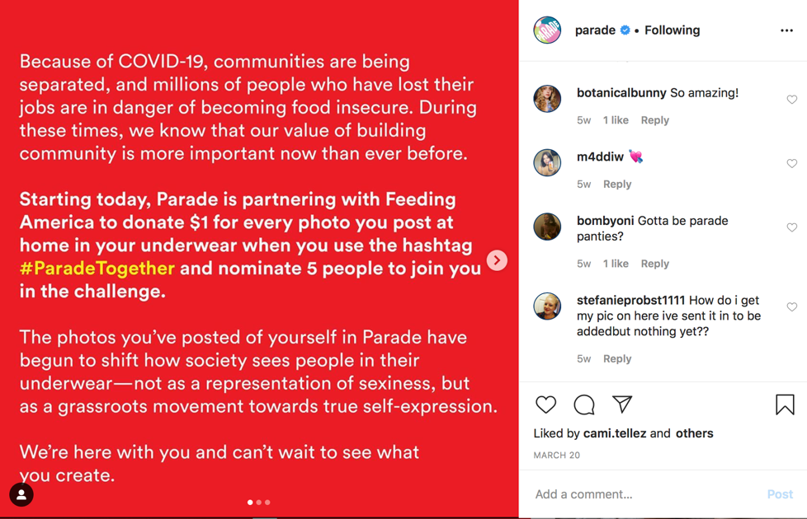
A new player in the arena of body-positivity underwear lines and sustainable brands, Parade has taken the marketplace by storm with its marketing strategy based on user-generated content and with an emphasis on community through its brand identity. The brand takes inclusivity to a whole new level from its models (representing all body shapes and skin colors), size range (XS to 3X), website name (yourparade.com), to its product development inspired by 500+ Parade friends via Slack.
The company also values its social responsibility as a dedicated partner of Planned Parenthood where a proceed of all Parade sales are donated to. Additionally, the brand recently launched a social media campaign to support Feeding America’s work in response to COVID-19.
Parade pledged to donate $1 for every tagged post of users in Parade and encouraged them to challenge others. This sparked a nationwide campaign (currently underway) with dozens of users creating and sharing content each day with #ParadeTogether.

Policy/Corporate Change Recommendations
- Company Culture
In light of the recent crisis, Brandy Melville’s first priority should be to strengthen its internal culture in order to create long-term positive experiences and relationships both internally and externally.
The company should launch a hiring initiative to expand the representation of individuals with different body types and skin colors. Brandy Melville should work with the human resources department to create new job postings and model castings.
The diversity and inclusion committee will play a critically role in the hiring process and guide the initiative.
To increase company morale, Brandy Melville needs to establish shared guiding principles for its company culture that employees are should adhere to. These codes of ethic will draw on the company’s values of body positivity, diversity, inclusivity, transparency, and open two-way communication.
Once these principles are created, regional managers should meet one-on-one either virtually or in-person with store managers for a company-wide retraining.
- Sizing Policy
As soon as possible, the company needs to rewrite its sizing policy to include all body types with sizes ranging from at least extra small to extra large. As the company relies heavily on its e-commerce business, partnering with True Fit, the size personalization platform, will increase web traffic and help shoppers better understand Brandy Melville’s newly offered sizes.
- Communicating Brand Values
Brandy Melville needs to publicly establish who it is as a brand and promote it in all of its messaging and media.
The website needs to include a mission or vision statement as well as an “About Us” section to contribute to its promise for more transparency and open communication.
Additionally, in order to convey itself as an inclusive, diverse and body-positive brand, the company will need to revamp its social media and website presence to include diverse range of models. A specific landing page on the website and a story highlight on Instagram should be dedicated to its new sizing policy as well.
Note on Global Communication
As a global brand, it is important for Brandy Melville to be aware of its various audiences and their cultural contexts. Although the company focuses its business strategy on the United States’ market, communication strategies should recognize all markets and respond accordingly.
For instance, social movements like body positivity and inclusivity are mostly widespread in Western countries. Some countries may not be accustomed to this collective effort; however, the company should not assume their reaction to resulting company-wide policy changes. It may require Brandy Melville to provide further context of these movements and incorporate them into the retraining sessions with supervisors.
Additionally, Brandy Melville should be prepared for varying reception to publicity efforts and brand image repair. Media relations may not be perceived in the same way as the United States where information spreads rapidly and companies respond immediately.
The most important elements of crisis response, which will vary regionally, will be the initial response.
- Be aware of cultures where uncertainty avoidance is valued more than accuracy and vice versa. This usually goes hand-in-hand with choosing to prioritize short-term or long-terms results.
- Assess if the culture prefers affective or neutral responses and alter apology statements accordingly.
- In regard to body positivity and diversity and inclusion initiatives understand which cultures are inner-directive and which are outer-directive to anticipate public reactions to policy changes.
In conclusion, it is crucial to also understand the role of fashion and clothing on an individual and a cultural level. Regardless of the region, stakeholders’ relationship to apparel can impact their perception of Brandy Melville in favor of or to the disadvantage of brand.

*To be posted on the Brandy Melville website page titled “Announcements”, emailed to all employees, shared on all social media accounts worldwide and posted on all storefronts.
A Letter to Our Customers and Employees

Dear Friends,

We are responding to you directly for helping us realize our role in today’s fashion industry and for giving us the chance to correct our wrongs. We have always been so grateful of our customers and employees who open our eyes to new ideas and opportunities each and every day through the clothes you love, the bands you adore and the movements and social issues you are passionate about. We write to you because we failed to support and respond to you in last case.
In a society where not only ideas but also individualism and diversity are encouraged, embraced and expressed, we should have been alongside you as you set the trend for what matters. Our former team members recently shared of their experiences, which brought to light our shortcomings. We are sorry for our failure to foster an environment of open communication and advocacy. While certain details of their experience remain unknown, the mere publication of this article shows that we could have done better and are actively working with the Equal Employment Opportunities Commission to understand the roots of these frustrations and to address them right away with guidance from our new diversity and inclusive committee.
Our first priority is to make the necessary changes to our practices based on our faults. This entails assessing our company culture and implementing stronger training programs and hiring initiatives to improve our internal culture to reflect in our everyday interactions with our dear customers.
We will be and should be more transparent and open with our employees and customers as they are an essential part of, not only our journey, but of who we are. We are grateful for our community who is helping us learn from our errors, and we promise we will not disappoint and will exceed your expectations in the future. We are committed to updating you regularly on our findings and changes and to continue collaborating with experts and our community as move forward from how we hire, to the clothes we design, to the messages we push forward and the social responsibility we are a part of. You have always inspired us and continue to inspire us to strive for bolder and better.
With love,
Brandy Melville
Sample Press Interview Q&A

Q: How will this affect the company’s bottom line?
A: Our top priority is to ensure our employees and customers are supported and heard as we work to address and resolve the matter at hand and to better ourselves to avoid any issue like this from happening again. Our bottom line may be impacted, but it is currently the least of our concerns as we are learning and improving ourselves in response to our current situation.

Q: Why did it take so long for the company to speak to allegations dating back to 2014?
A: Thank you for your question. Indeed, allegations dating back to 2014 can alarm readers, but we trust our store and regional managers and their adherence to policy and reporting that we immediately partnered with the Equal Employment Opportunity and Commission to look into all of our reports and internal communication. We are still investigating these instances and will update the public as soon as we learn more.

Q: In a recent press release, the company announced the expansion of its sizing policy, will this impact to the price for consumers?
A: No, customers will not see a change in prices now that our clothing is offered in sizes from XS to 3XL. We are pleased to provide a range of sizes that will cater to all body types while everything our dear customers love about Brandy Melville will stay the same.

Q: At one point, everyone wanted to be “The Brandy Girl”, so who is “The Brandy Girl” now?
A: Our identity is more than just title. At Brandy Melville, we want to celebrate young women who are bold, inspiring and empowering. Our clothes are designed for girls to not only love how they look in them but for how they feel in them—that is the fundamental part of who we are.

Q: Was anyone fired in response to the NYTimes piece? If so, why and if not, why not?
A: Thanks for your question. No, at this moment, no one has been fired as a result. As I mentioned, this is an ongoing investigation and elements of it may change, but our goal is to look at how can we as a brand and a company be better and learn from this rather than to just diminish it as quickly as we can. If our findings put us in the position where we have no other choice than to let go a team member, we will do whatever’s best for our customers and employees well-being and safety.

Q: How can you (Jennifer Foyle) be prepared to take on the role as media spokesperson for a company you just joined?
A: I love that question, because it was the first question that I asked myself when I was first approached by Brandy Melville to join the team. I have led and been a part of numerous inspiring initiatives at companies who want to be more than just a brand. They want to engage socially and connect with consumers and employees as much as possible. When Brandy Melville reached out to me, I noticed they had that same desire. So, I think my experiences have prepared me for this exciting role, and I am lucky to have a supportive team that has opened themselves to me and taught me so much already about the company and its story.

Q: Why should I support this brand now?
A: Great question. This has been a defining moment for us and a learning opportunity about all the various aspects of our company we can be better at. We understand that your trust in our company was been breached, but we want to assure you that through our actions and words that we have made it our top priority to learn from this and examine how we can be a company that you can unquestionably trust and rely on to support you in the store, online, on Instagram and beyond. We hope to strengthen our relationship with you, our customers and our employees, throughout this journey because you who make us who we are.

Q: Please explain why you have declined to comment in the past and chose to speak now.
A: Thank you for the question. We recognize that our decision to decline comment on certain topics created a cloud of confusion and distrust between us and our customers and employees. That was the first and most important lesson we’ve learned and since our first public response we refocused our efforts on transparency and two-way open communication, because we realized that you are the reason we’re running and we need your feedback, frustrations and concerns to strengthen our relationships with you and be more than just a brand, but a place for community and inclusivity.

Q: Will your lawyers threaten the former employees who spoke out with a lawsuit?
A: Our leadership team is focused on verifying and understanding where the described issues stemmed for and to make the appropriate structural and policy changes. Our legal team advises us on how to proceed so that we are protecting our employees and customers’ safety and information. Lawsuits only occur when an individual or group conflicts with our commitment and obligation to reasonably and lawfully protect those parties.

Sample Press Release

FOR IMMEDIATE RELEASE:

Brandy Melville Announces New Size Range on Apparel from XS to 3XL In Stores and Online In Partnership With True Fit

(New York, NY - APRIL 28,2019) Today we announce our new sizing policy implemented in all of our store locations worldwide as well as our e-commerce business and retail partner locations. Brandy Melville has removed all apparel tagged “one-size” from its physical locations and replaced them with a variety of sizes from XS to 3XL to cater to all of our customers who range in body types and wear Brandy Melville clothes each in their own unique way.

Our sizing was determined with the guidance and advice from experts at True Fit, the size personalization platform used by dozens of renowned and trusted retail companies worldwide. We are also pleased to announce that True Fit measurements will be available on our website as well for a better understanding of how our garments fit.

“We recognize the insensitivity and the exclusionary nature of our sizing policy and we sincerely apologize for the impacts it has had on our dear customers. Our customers inspire us and make up who we are,” Jennifer Foyle, the spokesperson for Brandy Melville said. “So, it is unacceptable for us to continue to foster any insecurities, and we are sorry it took us this long to realize that. We promise to be better by not only fixing our mistakes, but also holding ourselves at the highest standard of inclusivity and promoting body positivity.”

Brandy Melville is in collaboration with the nonprofit “The Body Positive” to provide resources and support on social media for its over four million Instagram followers. The two will continue to work together to offer events, push initiatives and offer exciting opportunities for customers and the company in an effort to promote body positivity and inclusivity in the fashion industry and beyond.

About Brandy Melville
Brandy Melville is more than just a clothing brand. We are trendsetting fashion inspired by young women for young women all over the world. Founded in Italy and later establishing our home in the United States, Brandy Melville apparel is offered worldwide through store locations and e-commerce.
###

